

#### TECHNICAL CONSULTATION PROPOSAL

##### Design, Build & Scale

**Client Info:**

**Name: <<client_name>>**

**Email:** [**<<client_email>>**](mailto:Sahil11@gmail.com)

**Phone: <<client_phoneno>>**

**Location: <<client_location>>**

**Date: <<date>>**

+12088421478

[info@appsynergies.com](mailto:info@appsynergies.com)

186 Malvern Avenue, Harrow, HA2 9HD, UK AppSynergies Pvt Ltd, D-1602, Orchid Suburbia, Link Road, Kandivali West, Mumbai 400067, India

2

 [www.appsynergies.com](http://www.appsynergies.com/)

Table of Contents

* Company Overview 3
* Our Services 4
* Our Approach 6
* Team Expertise 7
* Business Requirements & Project Overview 8
* Project Pricing 15
* Project Timeline 17
* Client Onboarding 18
* Terms & Conditions 19
* Client Testimonials 20
* Case Studies 21
* Contact Us 23

[info@appsynergies.com](mailto:info@appsynergies.com)

+12088421478

3

 [www.appsynergies.com](http://www.appsynergies.com/)

## COMPANY OVERVIEW



Why Us?

    

|  |  |  |  |  |  |
| --- | --- | --- | --- | --- | --- |
| **100+** | **50+** | **50+** | **100+** | **50+** | **10+** |
| **Projects** | **Apps** | **Websites** | **Happy** | **Technical** | **Years** |
| **Completed** | **Developed** | **Developed** | **Clients** | **Team** | **Experience** |

About Us

Driving Growth Through Technology and Marketing. We help businesses thrive in the digital landscape. From crafting innovative AI-driven apps and websites to executing high-impact SEO, ASO, SMM, content, and email marketing strategies, we deliver measurable results that matter.

We are a fast-growing business with a very talented and rapidly expanding team. We specialize in Design, Development, Testing, Release & Project Management of AI driven apps & websites. We also specialize in Digital Marketing Services like SEO, ASO, SMM, Content & Email Marketing.

Mission

To be a part of people's daily lives by helping them build lasting relationships in an environment of trust & respect.

Vision

To be one of the leading technology & marketing companies in the world, admired for its innovative products & services thereby contributing to a better & sustainable world.

[info@appsynergies.com](mailto:info@appsynergies.com)

+12088421478

4

 [www.appsynergies.com](http://www.appsynergies.com/)

## OUR SERVICES

App Design & Development

At AppSynergies, we build well-designed and optimized custom mobile applications with a delightful UX for both iOS and Android.

 iOS Android

Flutter



 React JS

 Firebase

AI Automations

At AppSynergies, we help you to transform your business with AI & drive growth. Automate repetitive tasks, boost productivity, and make smarter decisions with our powerful AI solutions!

 AI Calling  Chatbots

Make

Automations

GHL

Automations

 ManyChat Automations

[info@appsynergies.com](mailto:info@appsynergies.com)

+12088421478

5

 [www.appsynergies.com](http://www.appsynergies.com/)

Website Design & Development

At AppSynergies, we offer a complete range of website services that build up business value, from the initial idea and formulation of product strategy, through building a prototype and testing it with users, right to the creation of the product itself.



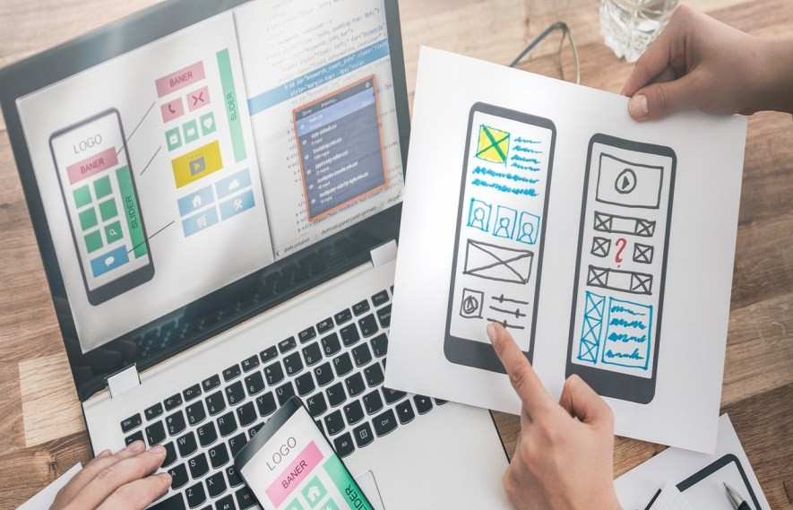Digital Marketing



Custom Website Design

E-Commerce Development

Responsive Web Design

Content Management System (CMS)

Web Maintenance & Support



We are an AI driven digital marketing agency empowering your business to innovate, optimize & grow in your market using AI-fueled marketing strategies. Our team of experts has over 5 years of experience in the digital marketing industry.

SEO

Social Media Marketing

Content Marketing



 PPC Advertising  Email Marketing Influencer

Marketing

Manual & AI Sales Service



[info@appsynergies.com](mailto:info@appsynergies.com)

+12088421478

6

 [www.appsynergies.com](http://www.appsynergies.com/)

## OUR APPROACH

###### Technical Services

* We begin by researching your industry and audience to create a tailored strategy.
* Our creative team crafts visually stunning and user-friendly apps and websites.
* We offer a complete range of technical services that build up business value.



[info@appsynergies.com](mailto:info@appsynergies.com)

+12088421478

7

 [www.appsynergies.com](http://www.appsynergies.com/)

## TEAM EXPERTISE



Our team comprises of experts in various technical & marketing fields with approximately 5 - 10 years of experience & knowledge in delivering complex projects.

You will have the below list of experienced professionals working on your project:

* Project Manager:<<pm_no>>
* Business Analyst:<<ba_no>>
* UI/UX Members:<<uix_no>>
* Backend Developers:<<bd_no>>
* Frontend Developers:<<fd_no>>
* AI/ML Developers:<<aiml_no>>
* System Architect:<<sa_no>>
* AWS Developer:<<aws_no>>



[info@appsynergies.com](mailto:info@appsynergies.com)

+12088421478

8

 [www.appsynergies.com](http://www.appsynergies.com/)

Business Requirement & Project Overview



**User Registration and Verification:**

1. User Sign-Up & Login: Users can create accounts using email, social media, or SSO authentication.
2. Two-Factor Authentication (2FA): Additional security measures like OTP verification or authentication apps.
3. Onboarding Questionnaire: Users provide details about their profession and AI tool preferences for personalized recommendations.
4. Profile Management: Users can update personal details, saved tools, preferences, and notification settings.
5. Email Verification: Users must confirm their email address before accessing full platform features.
6. Role-Based Access: Different access levels for users (general users, tool contributors, admin).
7. Saved & Favorited Tools: Users can bookmark AI tools for easy access later.
8. Subscription & Notifications: Users can opt into newsletters and receive updates on new AI tools.
9. User Dashboard: A personalized dashboard showcasing recommended AI tools, saved searches, and recent activity.

[info@appsynergies.com](mailto:info@appsynergies.com)

+12088421478

9

[www.appsynergies.com](http://www.appsynergies.com/)

1. Activity Tracking: Users can view their browsing history, reviews posted, and engagement with AI tools.
2. Review & Contribution Access: Verified users can leave reviews and suggest AI tools for inclusion.
3. Privacy Controls & Account Deactivation: Users can manage their data preferences and delete their accounts if needed

**Modular Architecture**

1. Scalable Infrastructure: Designed to support future feature additions and increased user traffic without performance issues.
2. Microservices-Based Architecture: Independent modules for search, user authentication, AI recommendations, and tool management.
3. AI-Powered Search Module: A separate, intelligent search engine that dynamically suggests AI tools based on user inputs.
4. AI Tools Database Module: A structured system for categorizing and managing AI tools, including filtering by category and relevance.
5. User Authentication Module: Secure authentication system with email, social login, and two-factor authentication (2FA).
6. User Profile & Personalization Module: Saves user preferences, history, and recommended AI tools for a tailored experience.
7. AI Tool Detail Page Module: Dedicated pages for each AI tool, featuring descriptions, reviews, comparisons, and alternatives.
8. Affiliate & Monetization Module: Integration of affiliate links, lifetime deals, and future direct purchase options.
9. Content Management System (CMS): Admin-controlled system for managing blog posts, newsletters, case studies, and user-generated content.
10. SEO Optimization Module: Ensures high-ranking visibility with keyword integration, structured data, and optimized page performance.
11. Newsletter & Blog Automation Module: AI-assisted content creation and automated email marketing for user engagement.
12. CRM Integration Module: Seamless connection with Go High Level CRM for lead tracking, client interaction, and marketing automation.
13. Dynamic Suggestion Engine: Real-time AI-powered recommendations based on user behavior, search history, and preferences.
14. Admin Dashboard Module: Centralized control for managing AI tools, user data, analytics, and content updates.

[info@appsynergies.com](mailto:info@appsynergies.com)

+12088421478

10

[www.appsynergies.com](http://www.appsynergies.com/)

1. Future Expansion Readiness: Easily extendable architecture for adding payment gateways, user-submitted tools, and advanced AI functionalities.

**Website Features**

1. AI-Powered Search Engine: Users can input their profession or needs to receive relevant AI tool recommendations.
2. Comprehensive AI Tools Directory: A categorized database of AI tools with filtering options based on industry and use case.
3. AI Tool Detail Pages: Each tool has a dedicated page with descriptions, images/videos, reviews, pros & cons, alternatives, and external links.
4. User Registration & Authentication: Secure sign-up and login system with email verification and social login options.
5. Personalized Dashboard: Users can view saved tools, recommended AI tools, browsing history, and recent activity.
6. New Arrivals & Trending Tools Section: Highlights the latest AI tools and most popular tools based on user engagement.
7. Affiliate & Monetization Integration: Referral links and lifetime deals for monetization opportunities.
8. SEO-Optimized Content: Blog, case studies, and newsletters with SEO-friendly content for higher search engine ranking.
9. User Reviews & Ratings: Users can submit feedback, rate tools, and contribute

insights on each AI tool’s effectiveness.

1. Newsletter & Blog Automation: AI-powered blog and email marketing automation to keep users engaged with updates.
2. CRM Integration: Seamless connection with Go High Level CRM for managing client interactions and marketing campaigns.
3. Dynamic Suggestions: Real-time tool recommendations based on user searches and browsing behavior.
4. Admin Panel for Content Management: A backend system for adding and updating AI tools, blogs, and managing user data.
5. Mobile-Responsive Design: Optimized for seamless browsing on desktops, tablets, and mobile devices.

[info@appsynergies.com](mailto:info@appsynergies.com)

+12088421478

11

 [www.appsynergies.com](http://www.appsynergies.com/)

**Phase 1 Features**

1. AI-Powered Search Engine – Users can input their occupation or needs to find relevant AI tools.
2. Comprehensive AI Tools Directory – Categorized listing with filtering options for easy navigation.
3. AI Tool Detail Pages – Dedicated pages with descriptions, reviews, pros & cons, and alternatives.
4. User Authentication & Profile Management – Secure login, onboarding, and personalized dashboards.
5. Affiliate & Monetization Integration – Referral links for earning commissions on AI tool recommendations.
6. SEO-Optimized Content – Blogs, newsletters, and case studies to drive organic traffic.
7. Admin Panel for Content & User Management – Manage AI tools, user accounts, reviews, and blogs.
8. CRM Integration (Go High Level) – Track client interactions and automate marketing.
9. Dynamic AI Recommendations – Smart suggestions based on user input and browsing behavior.
10. Newsletter & Blog Automation – AI-assisted content creation and automated email marketing.

**Phase 2 Features**

1. Payment System Integration – Enable direct purchases of AI tools.
2. Lifetime Deals Module – Offer exclusive, one-time deals on AI tools.
3. User-Submitted Tools – Allow users to submit and review AI tools for inclusion in the directory.
4. Advanced AI Recommendations – Enhance search results with improved AI algorithms.
5. Affiliate Dashboard for Earnings Tracking – Users and admins can track affiliate commissions and payouts.
6. Marketing Automation Enhancements – Improved email, social media, and retargeting strategies.
7. Community & Discussion Features – Enable forums or discussions for user engagement.

[info@appsynergies.com](mailto:info@appsynergies.com)

+12088421478

12

[www.appsynergies.com](http://www.appsynergies.com/)

1. Advanced Analytics & Reporting – Deeper insights into user behavior, tool performance, and revenue tracking.
2. Premium Membership Options – Offer paid access to exclusive AI tool insights, deals, and features

**Admin Panel**

1. AI Tools Management: Add, edit, and categorize AI tools with descriptions, images, and affiliate links.
2. User Management: View, edit, and manage user accounts, authentication statuses, and activity logs.
3. Content Management System (CMS): Create, edit, and schedule blogs, newsletters, case studies, and SEO content.
4. Reviews & Ratings Moderation: Approve, delete, or respond to user reviews and ratings for AI tools.
5. Dynamic AI Recommendations Control: Adjust AI tool recommendations and ranking algorithms for better user experience.
6. Affiliate & Monetization Tracking: Monitor affiliate link performance, referral earnings, and commission reports.
7. SEO & Metadata Control: Optimize tool listings, blogs, and pages for search engine rankings.
8. Analytics & Reporting Dashboard: Track user activity, search trends, tool popularity, and website traffic insights.
9. Newsletter & Email Automation: Manage email campaigns, subscriber lists, and AI-generated content distribution.
10. Security & Access Control: Role-based permissions for different admin users, ensuring data protection and secure access.

**Integrations**

1. Go High Level CRM Integration: Seamless connection for managing client interactions, leads, and marketing automation.
2. Affiliate & Monetization Platforms: Integration with affiliate networks to track referrals and earnings.
3. SEO & Analytics Tools: Google Analytics, Search Console, and other SEO tools for tracking website performance.
4. Email Marketing Automation: Integration with platforms like Mailchimp or SendGrid for newsletters and user engagement.

[info@appsynergies.com](mailto:info@appsynergies.com)

+12088421478

13

[www.appsynergies.com](http://www.appsynergies.com/)

1. Social Media & Sharing Tools: Easy sharing options for AI tools on LinkedIn, Twitter, and other platforms.
2. YouTube & Video Embeds: Support for embedding video reviews and tutorials from YouTube.
3. Payment Gateway (Phase 2): Future-ready integration for processing direct purchases and lifetime deals.

**Comprehensive Management and Support System for the Platform**

1. Centralized Admin Dashboard – A unified panel to manage AI tools, users, content, and integrations efficiently.
2. User Role Management – Assign roles (admin, moderator, user) with different permission levels.
3. AI Tool Database Management – Add, update, categorize, and remove AI tools with ease.
4. User Account Management – Track and manage user registrations, profiles, and activity.
5. Review & Feedback Moderation – Approve, edit, or remove user-submitted reviews and ratings.
6. Affiliate & Earnings Management – Track affiliate referrals, commission payouts, and analytics.
7. SEO & Content Optimization Panel – Manage meta tags, keywords, and SEO settings for improved search rankings.
8. Email & Notification System – Automated email and push notifications for user engagement.
9. Dynamic Search & AI Recommendations Control – Adjust AI search algorithms for better user results.
10. Newsletter & Blog Automation – AI-powered content generation and automated publishing.
11. CRM Integration & Lead Tracking – Seamless Go High Level CRM integration for marketing and client management.
12. User Support Ticket System – Built-in helpdesk for user inquiries, troubleshooting, and assistance.
13. Live Chat & AI Chatbot Support – Real-time user assistance via chatbots and live agents.
14. Data Backup & Recovery System – Regular automated backups for security and data protection.
15. Performance Monitoring & Optimization – Track page speed, uptime, and performance metrics.

[info@appsynergies.com](mailto:info@appsynergies.com)

+12088421478





14

[www.appsynergies.com](http://www.appsynergies.com/)

1. Analytics & Reporting Tools – Insights into user behavior, AI tool popularity, and revenue tracking.
2. Security & Access Control – Implement security measures like two-factor authentication (2FA) and role-based access.
3. Community & Forum Management – Manage discussions, user engagement, and content moderation.
4. Scalability & Future Expansion Planning – Modular architecture for seamless integration of new features in future phases.

Note:

In the initial phase we would be designing & prototyping the website/app/admin panel to show a demo of how it the flow will be and with the click of each button, what will be the situations that we would have to handle to ensure ease of use of the platform.

The points mentioned will be taken care of, feedback from the client will be our priority and depending of the feedback, situations & use cases, these features might be changed accordingly.

[info@appsynergies.com](mailto:info@appsynergies.com)

+12088421478

15

 [www.appsynergies.com](http://www.appsynergies.com/)

## PROJECT PRICING

**Designs <<design>>**

**Development <<development>>**

**Testing & Deployment <<test_deploy>>**

**Annual Maintenance <<annual_mainte>>**

**Total Amount <<total_amount>>**

This annual maintenance fee covers the charges to make sure the platform is live and always running properly. If there are any live bugs or anything goes wrong with the platform then we will make sure it is fixed and deployed as soon as possible. We also regularly check & run tests on the platform to make sure everything is working fine.

**Additional Features <<ad_f>>**

**& Enhancements**

We would be charging this amount for a team (1 BA/PM, 1 UX, 1 Dev, 1 QA) per week (5 days/40 hrs) on project work after the project completion for any ongoing enhancements, features that the client would want after release.

[info@appsynergies.com](mailto:info@appsynergies.com)

+12088421478

16

 [www.appsynergies.com](http://www.appsynergies.com/)

###### Payment Method

**AppSynergies Pvt Ltd accepts the following payment method:**

* Bank Transfer
* Credit Cards and Debit Cards
* Net Banking
* Gpay or Paytm

###### Payment Schedule

|  |  |
| --- | --- |
| **Sr No.** | **Schedule** |
| 1 | Before starting the project, the client needs to pay 30% of the total or the estimated amount. |
| 2 | On 50% project completion, the next 40% payment needs to be released. (After getting UI UX Design Approved) |
| 3 | Once the project gets completed the client needs to pay the rest 30% of the total amount before getting the handover. |

**Note:** We are happy to offer 10% discount if you can sing the contract & start the project withing 48 hours.

Next Steps:

Our proposal is valid for a week. To take advantage of this proposal and proceed with the project as outlined, the client next step must be to:

* Accept the proposal as-is
* Discuss desired changes with AppSynergies Pvt Ltd.
* Finalize and sign the contract
* Submit an initial payment as mentioned in the payment schedule section

Once completed, AppSynergies Pvt Ltd will connect you to schedule project launch meeting to make introductions and gather information before beginning the work.

We are happy to make changes to the project scope on your request at any time but this may be subject to additional billing.

[info@appsynergies.com](mailto:info@appsynergies.com)

+12088421478

17

 [www.appsynergies.com](http://www.appsynergies.com/)

## PROJECT TIMELINE

* 3-4 Weeks UI/UX Designs



* 4-6 Weeks  Development
* 2 Weeks  Testing & Live
* Overall Project Completion 3-4 Months

[info@appsynergies.com](mailto:info@appsynergies.com)

+12088421478

18

 [www.appsynergies.com](http://www.appsynergies.com/)

## CLIENT ONBOARDING



* **Initial Consultation**: We schedule a meeting to discuss your goals, needs, and expectations.
* **Proposal Presentation**: We present our tailored proposal, including pricing and project details.
* **Project Kickoff**: Once you approve the proposal, we initiate the project, assigning a dedicated team.
* **Regular Updates**: We provide regular progress updates and milestones.
* **Project Completion**: Upon project completion, we conduct thorough testing and hand over all deliverables.
* **Ongoing Support**: We offer post-launch support and assistance as needed.

[info@appsynergies.com](mailto:info@appsynergies.com)

+12088421478

19

 [www.appsynergies.com](http://www.appsynergies.com/)

### Terms & Conditions

Once the project fee is paid in full to AppSynergies Pvt Ltd, any elements of text, graphics, photos, contents, trademarks, or other artwork furnished to the client for inclusion in the website are owned by the client. AppSynergies Pvt Ltd assumes the client has permission from the rightful owner to use any code, scripts, data, and reports provided by the client for inclusion in its materials, and will hold harmless, protect, and defend AppSynergies Pvt Ltd from any claim or suit arising from the use of such work.

AppSynergies Pvt Ltd retains the right to display graphics and other web content elements as examples of their work in their portfolio and as content features in other projects. This agreement becomes effective only when signed by the client and AppSynergies Pvt Ltd. Regardless of the place of signing of this agreement, the client agrees that for purposes of venue, this contract was entered into in Mumbai, India and any dispute will be litigated or arbitrated in Mumbai, India.

The agreement in this contract constitutes the sole agreement between the client and AppSynergies Pvt Ltd regarding all items included.

**This proposal shall be valid until <<validity_date>>**

**Feel free to reach out to us at** [info@appsynergies.com](mailto:info@appsynergies.com) **or +12088421478 for any questions.**

**Signature Details**

Sneha Shukla

<<client_name>> Sneha Shukla

<<date>> <<date>>

We look forward doing business with you.

Thank You, Team AppSynergies

[info@appsynergies.com](mailto:info@appsynergies.com)

+12088421478

20

 [www.appsynergies.com](http://www.appsynergies.com/)

### Client Testimonials

**Eric**

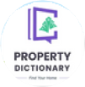

Sustainability Ledger, CEO

“Very good team with great understanding of apps. They helped me build my idea of energy estimation and management for household. Their development skills are second to none.”

**Benny C**



UCALL, CEO

“Selecting this team proved invaluable. Their professionalism, creativity, and prompt delivery greatly influenced our projects success. We’re grateful for their outstanding dedication!”

**Wai Chan**

My Wallet, CEO

“AppSynergies resolved major issues with the first version of the product, leading to sustained growth for us. Their development skills are second to none!”

**Asim**

Property Dictionary, CEO

“Working with this team was easy and fun. They really know their stuff, and our project turned out way better than we hoped. Looking forward to more projects together!”

**Ankur**

Edlighten, CEO

“They helped us build a psychometric test platform & AI ML Models which helped us analyze the thinking skills of students.”

**Musa**

Hola Home, CEO

“They developed a property booking platform for us. Very fast setup, good team work and handover by their side.”



[info@appsynergies.com](mailto:info@appsynergies.com)

+12088421478

[www.appsynergies.com](http://www.appsynergies.com/)

21

## CASE STUDIES

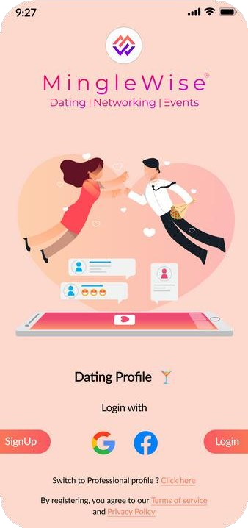

Deliverables

* **Technical Stack**
  + App: Flutter
  + Backend: Node JS,

Firebase

* + Admin Panel: Flutter
* Integrated AI for matchmaking, profile verification,

and event recommendations.

Worlds first all-in-one AI driven app for dating,

networking.



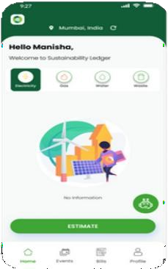

Deliverables

* **Technical Stack**
  + App: Flutter
  + Backend: Firebase
  + Admin Panel: Flutter
* Implemented real-time resource monitoring, analytics, carbon tracking, and community features

with robust data privacy.

Sustainability Ledger is an app that helps household

and small business track their resource usage.

[info@appsynergies.com](mailto:info@appsynergies.com)

+12088421478

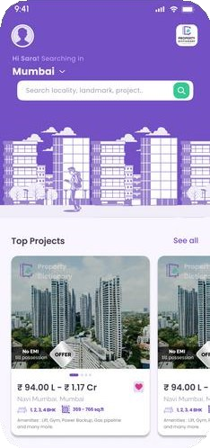

Deliverables

* Technical Stack
  + App: Flutter
  + Backend: Firebase
  + Admin Panel: Flutter
* Developed a property search app with curated listings, advanced filters, virtual tours, direct inquiries, and real-time

notifications.

Property dictionary is your go-to property dictionary app, offering a collection of listings with

comprehensive details.

[www.appsynergies.com](http://www.appsynergies.com/)

22

CASE STUDIES



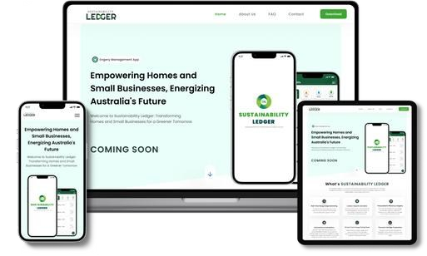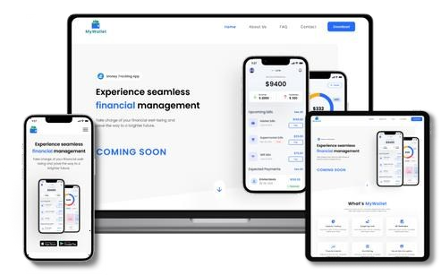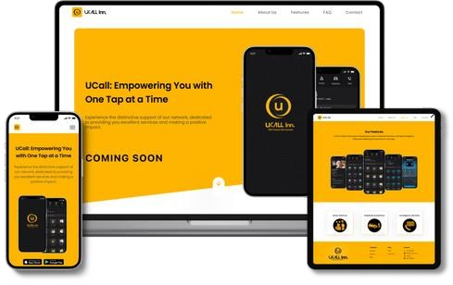

**Revolutionizing homes and small businesses for a more Sustainable tomorrow.**

* Real Time Energy Usage Monitoring
* Carbon Footprint Calculator
* Personalized Efficiency Insights
* Financial Savings Projections

**Take Control of Your Finances with Our Money Tracking App!**

* Expense Tracking
* Budget Management
* Income Analysis
* Financial Report

**Top-notch Services to users and assist in identifying the most fitting job opportunities for you.**

* + Access to Basic Services
  + Roadside Assistance Anywhere
  + Emergency Services at Your Call
  + Book any Service & get rapid response

[info@appsynergies.com](mailto:info@appsynergies.com)

+12088421478

23



 [www.appsynergies.com](http://www.appsynergies.com/)

# Contact Us

**Website** <https://appsynergies.com/>

**Phone** +12088421478

**Email** [info@appsynergies.com](mailto:info@appsynergies.com)

**Social Media**



**Address** 186 Malvern Avenue, Harrow, HA2 9HD, UK. D-1602, Orchid Suburbia, Link Road, Kandivali West, Mumbai 400067, India.



[info@appsynergies.com](mailto:info@appsynergies.com)

+12088421478